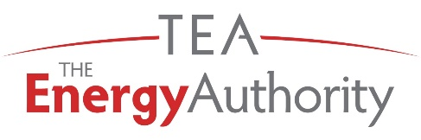
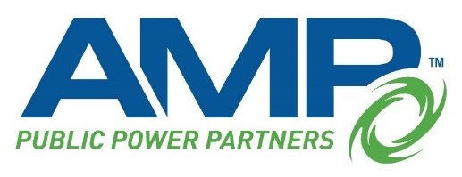

Solar RFP
American Municipal Power, Inc. (AMP) is a nonprofit wholesale power supplier and service provider for 135 members. AMP and its member communities are committed to the balance of being responsible corporate citizens, governmental entities, employers and environmental stewards, while maintaining a supply of cost-competitive, reliable electric power. One way AMP achieves this balance is through the consistent application of sustainability as a business practice.
In its continued, demonstrated commitment to a sustainable balance of cost-competitive, reliable electric power supply, AMP is opening a Request for Proposal (RFP) to procure renewable generation for several of their member utilities. AMP is seeking responses for projects in both PJM and delivered to the LGEE interface. Total contract capacity ranges from 100-150 MWac with a maximum capacity of 50 MWac for the LGEE delivered project. Term preference for these projects are between 10-30 years. Products are to include energy, capacity, and environmental attributes.
AMP is seeking bids for Full Attribute, Solar Generation Power Purchase Agreements (PPA) with a preferred Commercial Operation Date (COD) of 2023. Key tenets of project consideration are project viability, price, congestion risk, and deliverability.
As a trusted public power affiliate, The Energy Authority (TEA) is the administrator for this Request for Proposals (RFP).
To access the RFP document and term sheet, please visit TEA’s Procurement site:

teamarketplace.azurewebsites.net
For questions, please email: AMPRFP@teainc.org

